68k Disassembler

Thuan Tran

# Overview

In this section, I will go over how I work on the disassembler. I will talk about how I manage and break down the task

# How I manage the task

Luckily, the version control software that I used (GitKraken) has a feature that allow me to create a sprint board. Within the sprint board, I create these columns:

* Working on: Stuff I am working on
* Backlog: Stuff that needs to do
* Currently known bugs: Stuff that was done or needs to look again because of some issues but are fine at the moment
* Done: stuff that are done

At first, I had the idea of writing down in a document. But overtime, it grown too large and hard to keep track, so I switched to this sprint board

So here are the procedure of what I did to lead up to this :

* Work on getting user’s input and converting
* Work on simple instruction like NOP, RTS
* Work on instructions that start with 0,4,5,8,9 as the first nibble
* Work on instructions that start with 6, B,C,D,E
* Work on instructions that start with 1,2,3 (The move stuff)
* Reorganize the file
* Perform extensive testing
* Write documentation

During those activities, I combine both IO, EA and Opcode at the same time

I can say that I did 100% of the work. For the duration, here are what I recall

Starting at week 1, did not do much, just start reading the project and prepare

Middle of week 2, start to work on it. Mostly focus during Friday, Saturday and Sunday

From week 3 onward, spent at least an hour per day working on it . Some day were off, someday do extra

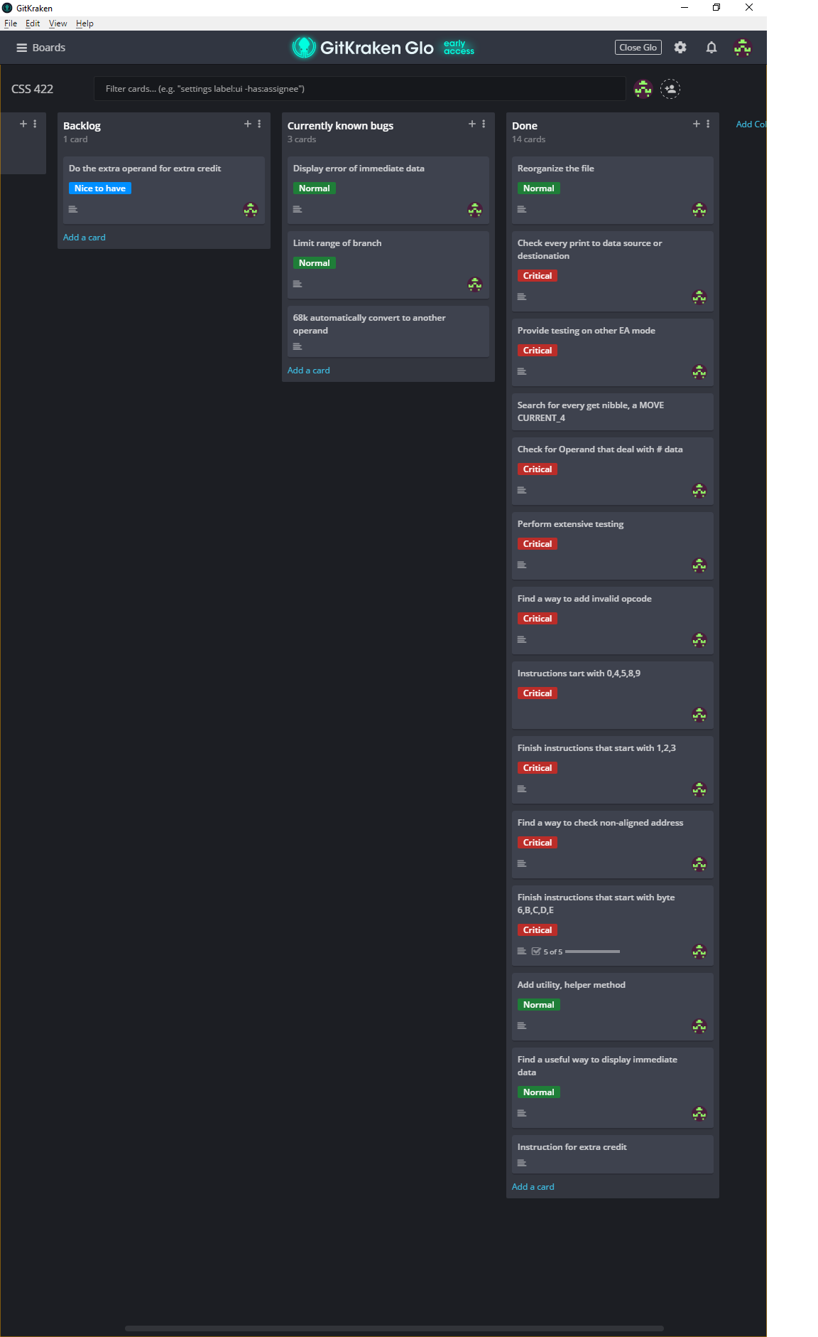

Figure Sprint board by GitKraken

# **Confidential Individual Evaluation Report**

I don’t think there are much to say within this section. My comment is the same as the submission for the confidential individual report on Canvas.